**Decimal & Binary Number System**

**1) Binary Number System:**

Computer understand the language of 0’s and 1’s that is binary language. The base of binary number is 2 that is only 0 and 1 are used to represent any number in the binary number system.

**Ex:** 10011

**2) Decimal Number System:**

Decimal number system is a number system that we use in our day-to-day life. The decimal number system has its base as 10 that is any number in the decimal number system is represented using the digits 0-9.

**Ex:** 678

**3) Binary to Decimal Conversion:**

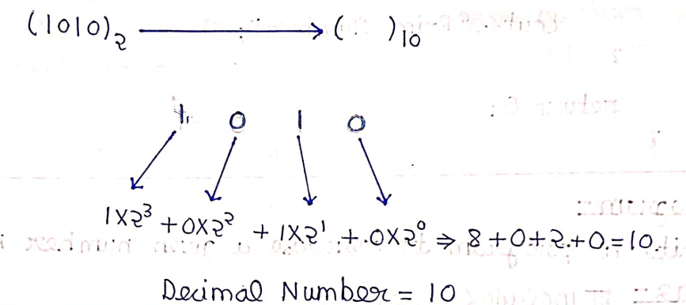

**4) Decimal to Binary Conversion:**

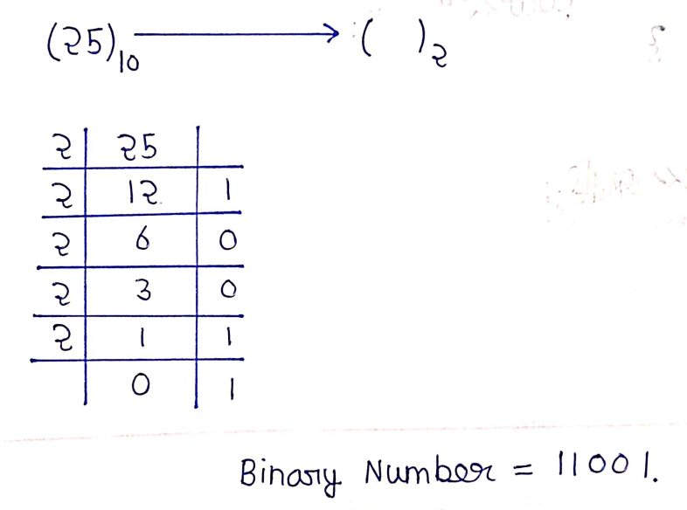

**5) Decimal to Binary Conversion Code:**

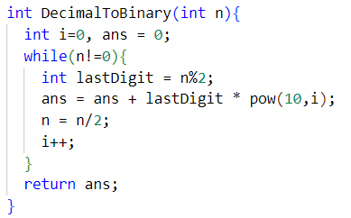

**6) Decimal to Binary Conversion Code:**

